BIO-DATA

Name: Supriya Priyadarshinee Naik

Date of Birth: | 09-05-1991 | 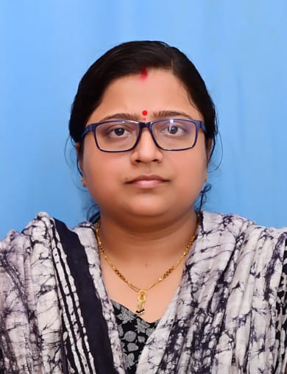
Present Address: | At/Po- Bedabahal, P.S.- Sadar Sundargarh, Dist.- Sundargarh, Pin- 770073, Odisha
Permanent Address: | Same as present address
E-mail Id: | supriyapnaik005@gmail.com
Mobile: | 9439105171, 8917518329
Father: | Mr. Jagada Nanda Naik
PROFESSIONAL CAREER

Completed Ph.D. as an INSPIRE Fellow from Dept. of Earth Sciences, Sambalpur University.

EDUCATIONAL QUALIFICATION

Year of  Passing | Exam Passed | University /  Board | Institution
2006 | 10th /HSC | BSE, Orissa | Bhedabahal Girls High School, Bhedabahal, Sundargarh
2009 | 12th/ +2 | CHSE, Orissa | Govt. Women’s JR. College, Sambalpur
2012 | B.Sc. | Sambalpur University | Govt. College, Sundargarh
2014 | M.Sc. (Applied Geology) | Sambalpur University | P.G. Dept. Of Earth Sciences, Sambalpur University
2015 | M. Phil (Applied Geology) | Sambalpur University | P.G. Dept. Of Earth Sciences, Sambalpur University
2024 | Ph. D., Geology | Sambalpur University | P.G. Dept. Of Earth Sciences, Sambalpur University

WORK EXPIRIENCE / INDUSTRY EXPOSURE / SUMMER INTERNSHIPS

- Summer internship of 3 months on exploration, quality and process control, mine planning and environmental monitoring and management at Jilling Longalota Iron and Mn mines, Keonjhar, EMIL (Aditya Birla Group), Odisha.
- Presently working as Guest faculty in Geology Department, Govt. College Sundargarh, Odisha.

ACADEMIC ACHEIVEMENT, AWARDS & SEMINARS

- Gold Medalist in M.Sc., P.G. Dept. of Earth Sciences, Sambalpur University, 2014.
- DST-INSPIRE FELLOWSHIP awardee for 2016-2022.
- Attended National Seminar at Sambalpur University on the topic "Recent advances in Earth Sciences"
- Attended Prithvi 2014 (National Seminar) at IIT Kharagpur.
- P.G. Diploma in Environmental Education and Management (PGDEEM), 2015.
- Attended National Workshop on “Art of Academic Writing and Publication Skills” at Gangadhar Meher University, Sambalpur, 2017.
- Presented a paper in the National Seminar on “Litho-. Hydro-, Bio- and Atmosphere in the Service of Mankind” organized by P. G. Department of Geology, Govt. College, Sundargarh. September 8-9, 2018.
- I have participated in Advanced trainning Programme on “Analytical Geochemistry” a CSIR Integrated Skill Initiative held at CSIR- National Geophysical Research Institute, Hyderabad from dt:04-03-2019 to dt:13-03-2019.
- Participated in “INSPIRE Fellowship Review Meeting 2019 sponsored by DST, Government of India” held at Kalinga Institute of Industrial Technology (KIIT), Bhubaneswar, Odisha from 6th to 8th June 2019.
- Attended and presented my work in one international seminar on the theme of “Climate, Water and Environment ( Limit- 2019)” at Uttarakhand Academy of Administration, Nainital organised by Humboldt club from dt: 25-09-2019 to dt:27-09-2019.
- Presented a paper in the National Seminar on “Sedimentation, Tectonics, Mineral Resources and Sustainable Development” and 36th Convention of Indian Association of Sedimentalogists organized by Atomic Minerals Directorate for Exploration and Research, Hyderabad. November 7-8, 2019.
- Attended the e-Training on “Refresher Course on Petrographic Techniques for Mineral Exploration” conducted by RTD, NER, GSITI, Shillong, GSI from 21.09.2020 to 26.09.2020.
- Presented a paper in the Online International Conference on “Recent Developments and challenges in Earth & Environmental Sciences, Natural Resource Management, & Climate change with special focus on Eastern Himalayas” organized by Department of Geology, Sikkim University. October 8-9, 2020.
- Attended the e-Training on “Refresher Course in Igneous Petrography, Petrogenesis and Geochemistry” conducted by Petrology Division of GSI Training Institute, Hyderabad from 08.10.2020 to 14.10.2020.

Research Papers Published

- Naik, S.P., Behera, D., Naik, A., Mohanta D.P. and Sahoo T.K. (2021). Lithological Diversity in Dhama Area, Sambalpur District, Odisha, India: Footprints of the Contact Between Bastar Craton and Rengali Province. Journal of Geosciences Research.,v. 6, pp. 146-154.

- Patra P.K., Behera, D., Naik, S.P. and Goswami S. (2021). Spatio-Temporal Variation of Vegetation and Urban Sprawl using Remote Sensing and GIS: A case Study of Cuttack City, Odisha, India. Journal of Geosciences Research.,v. 6.
Extra Curricular Activities, Memberships.

Language Known- Odia, Hindi, English, Folk Languages
Computer Skills – PGDCA,
Extra Curricular Activity- Debate, Essay, Anchoring, Event Management
Executive Body Member of AAG (Alumni Association of Govt. College Sundargarh)
Declaration

I do hereby declare that all the information provided above is true to the best of my knowledge and belief.

Date- 24-08-2024 Name- Supriya Priyadarshinee Naik

